Unlocking Societal Trends in Aadhaar

Enrolment and Updates

UIDAI Data Hackathon Submission
Team Brawlers –
Team ID – UIDAI_9222

i) Priyanshu Ranjan
ii) Pratham Kashyap
iii) Mukul Mishra
iv) Akshat Singhal

Abstract

Aadhaar is India’s main digital ID system, opening doors to welfare programs, banking, and government services for millions. With people signing up every day and regularly updating their details and biometrics, the system collects a huge amount of data. In this study, we dig into enrolment records and demographic and biometric updates from UIDAI, looking for trends in society, regional differences, how things change over time, and any odd patterns in the data. By exploring and visualizing this information, we spot important insights that help with smarter decisions, better infrastructure, and stronger systems. Our approach shows how using Aadhaar data directly boosts efficiency and shapes better policies.

1. Problem Statement and Approach
Problem Statement
The Aadhaar ecosystem is spearheading digital governance in India by supporting identity authentication needed for welfare and public service access and financial inclusion. With ongoing enrolment and regular demographic and biometric revisions, the UIDAI agency accumulates vast amounts of operational data. Nevertheless, data analysis for actionable insights pertaining to social data, demand by region, and operational efficiency continues to be a challenge. This project intends to classify social data related to Aadhaar enrolment and updates by evaluating three UIDAI datasets: enrolment, demographic updates, and biometric updates for the purpose of identifying:
• Pattern of time and geography,
• Behaviour of demographic-driven updates,
• Irregularities and surges in demand,
• Signals that may aid informed decision making and optimization of the system.

Analytical Approach
The suggested strategy relies on:
• Individual exploratory data analysis (EDA) for each dataset,
• Comparative analysis across datasets to determine potential relationships,
• Clear communication of insights through visual analytics,
• Policy and operational trend analysis interpretation.
The result is a framework of data-driven insights to support UIDAI in planning infrastructures, enhancing service access, and forecasting future demand for Aadhaar services.

2. Datasets Used
All datasets used in this study were officially provided by UIDAI, ensuring data reliability and relevance.
2.1 Aadhaar Enrolment Dataset
This dataset contains information related to new Aadhaar enrolments across India.
Key attributes used:
- State / UT
- District
- Enrolment counts
- Gender
- Age group
- Time period
Analytical focus:
- Regional enrolment distribution
- Temporal growth trends
- Demographic participation patterns
2.2 Aadhaar Demographic Update Dataset
This dataset records updates made to Aadhaar demographic details.
Key attributes used:
- State / UT
- District
- Type of demographic update
- Update count
- Time period
Analytical focus:
- Frequency and type of demographic changes
- Region-wise update dependency
- Life-event driven update behaviour

2.3 Aadhaar Biometric Update Dataset
This dataset captures biometric update activities.
Key attributes used:
- State / UT
- District
- Biometric type
- Age group
- Update count
- Time period
Analytical focus:
- Age-based biometric ageing patterns
- Regional biometric refresh trends
- Operational load distribution

3. Methodology
A structured data analytics pipeline was followed across all three datasets.
3.1 Data Cleaning
- Deletion of duplicates and unnecessary entries
- Management of absent and empty values
- Uniformity of dataset column headings
- Adjustment of naming discrepancies in states and districts

3.2 Data Preprocessing
- State-, district-, and time-based data aggregation
- Formatting of date fields to uniform time intervals
- Data age field consolidation into predefined age categories
- Dataset normalization to ensure equitable regional comparison

3.3 Data Transformation
- Trend and seasonality analysis through time-series aggregation.
- Measurement of update intensity.
- Enrolment ratio indicators (updates relative to enrolments).
- Anomaly detection via high-variance region identification.

3.4 Tools and Techniques
- Python (Pandas, NumPy) for data handling
- Matplotlib / Seaborn for visualisation
- Exploratory Data Analysis (EDA)
- Comparative and descriptive statistical analysis
All analysis was performed using Google Colab notebooks, which are included as part of the submission for transparency and reproducibility.
4. Data Analysis and Visualisation
4.1 Aadhaar Enrolment Analysis – Key Insights
- There are clear differences in Aadhaar enrolment across regions and consistent higher enrolment in some states.
- There is quicker saturation in enrolment in urban and semi-urban areas compared to rural areas which are growing steadily and are showing gradual saturation.
- From a gender perspective, there is fairly equal participation which reflects Aadhaar's inclusive outreach.
- There are time periods with significant increases in enrolment which may correlate with specific directives, policies, or enrolment campaigns.
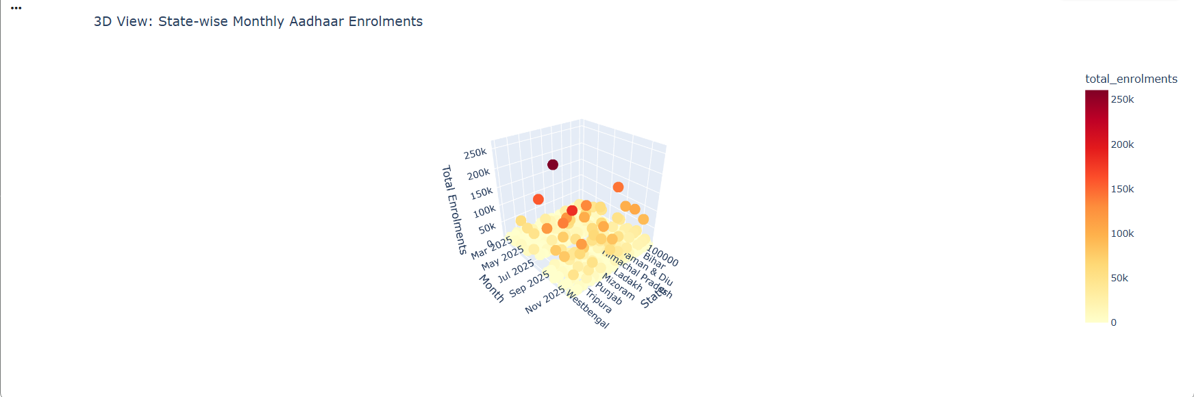
State-wise Monthly Aadhaar enrolment reveals significant regional variation, with a few states contributing disproportionately to total enrolments.

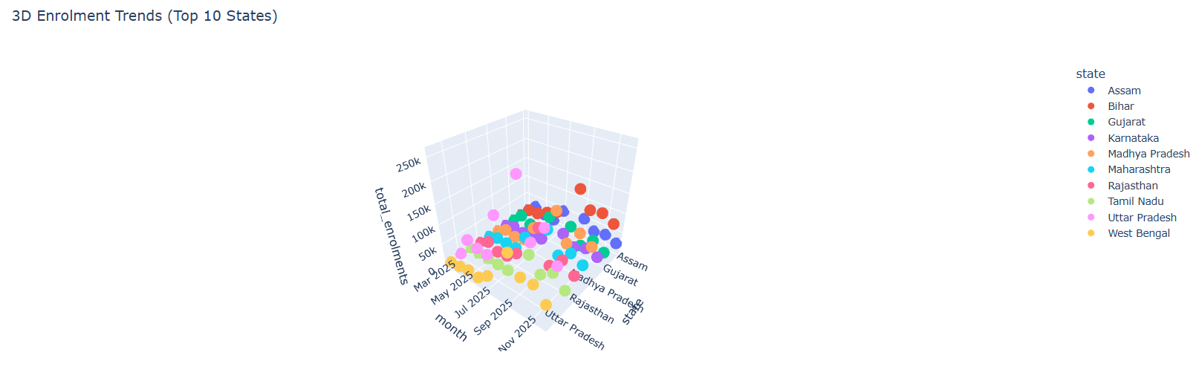
Temporal analysis highlights periodic enrolment spikes, indicating campaign-driven or policy-led enrolment initiatives.

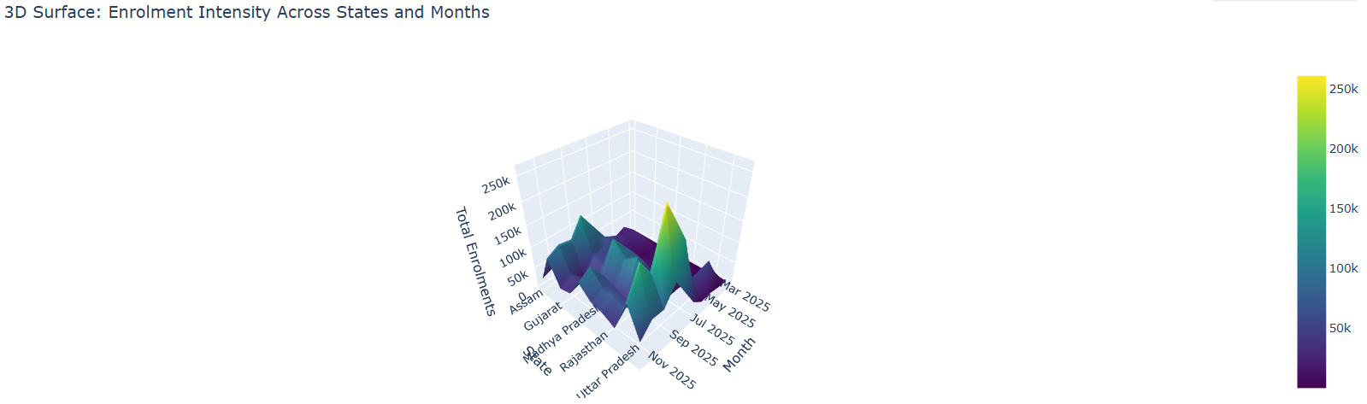
3D surface plot illustrating state-wise Aadhaar enrolment intensity over time, revealing significant regional differences and periodic enrolment surges across months.

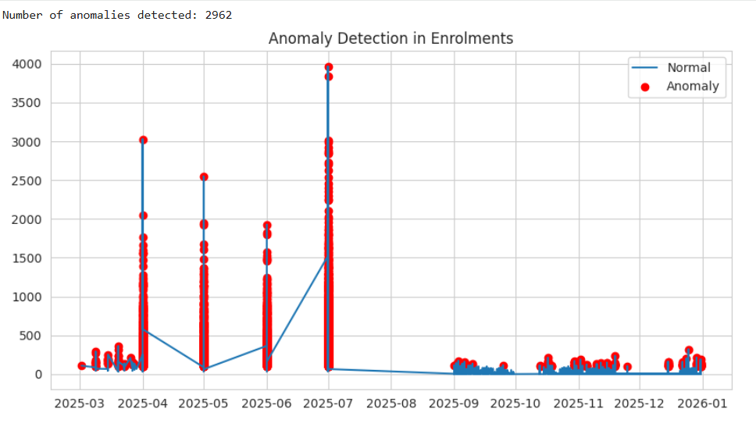
Anomaly detection in Aadhaar enrolment data highlighting significant deviations from normal enrolment patterns over time, which may indicate operational disruptions, policy-driven spikes, or data irregularities.

**The exploratory data analysis of Aadhaar enrolment trends was conducted using Python-based notebooks (see Enrolment Analysis Notebook, Appendix A).

4.2 Demographic Update Analysis – Key Insights
- Most demographic updates come from people changing their addresses or names—usually because they’re moving, studying, or switching jobs.
- Younger folks and people of working age update their info more often than others.
- Some regions always see a lot of these updates, which hints at either more people on the move or a bigger reliance on official paperwork there.
- Overall, the pattern doesn’t really change much over time. Aadhaar keeps proving itself as an ID that actually keeps up with people’s lives.

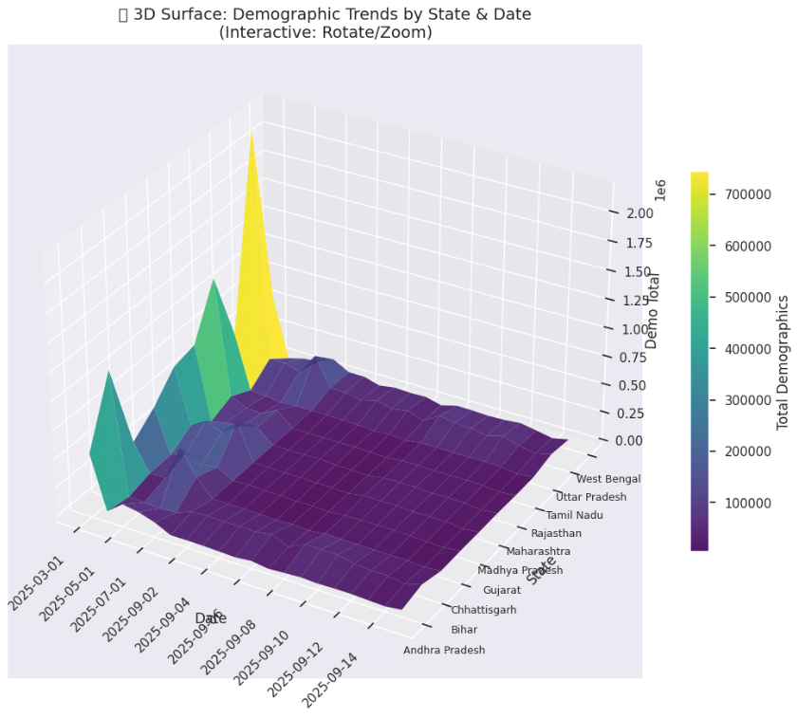
3D surface visualization of Aadhaar demographic update trends across states over time, illustrating regional variation and temporal fluctuations in demographic update volumes.

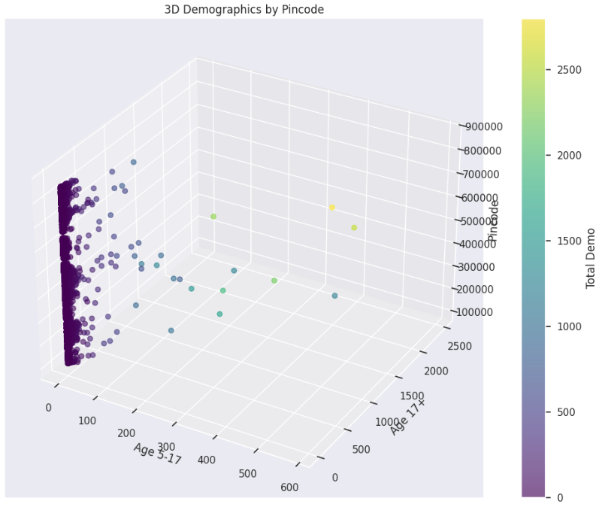
3D scatter plot illustrating Aadhaar demographic update distribution across PIN codes, age groups, and update volume, highlighting spatial and age-based variability in demographic update activity.
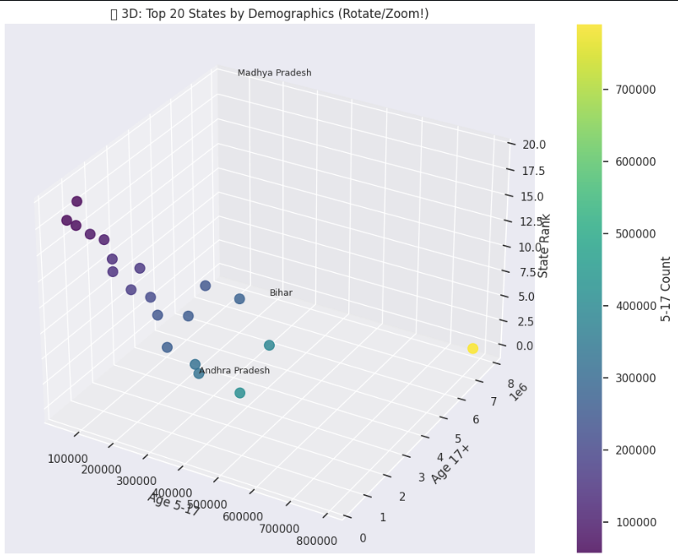
3D scatter plot of the top 20 states by Aadhaar demographic update volume, comparing age-group-wise update counts and state rankings to highlight inter-state disparities in demographic update demand.
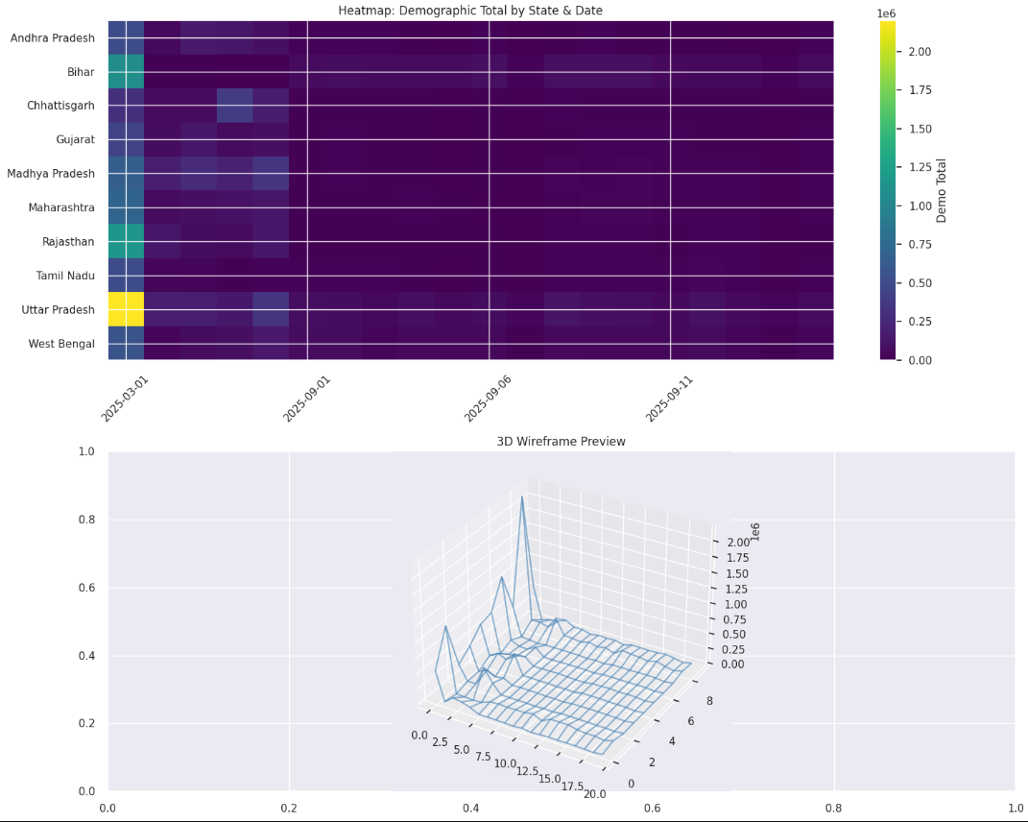
Heatmap and 3D wireframe visualization of Aadhaar demographic update totals across states and dates, highlighting temporal concentration and inter-state variability in demographic update activity.

**Detailed demographic update analysis, including state-wise and temporal visualisations, is presented in the Demographic Analysis Notebook (Appendix B).

4.3 Biometric Update Analysis – Key Insights
- Biometric updates really pick up as people get older, which backs up the idea of biometric ageing.
- Most of these changes show up in fingerprints, way more than in iris or facial data.
- In a few districts, the number of updates is unusually high. That probably means the original scans weren’t great, or maybe things like local work and environment are messing with people’s biometrics.
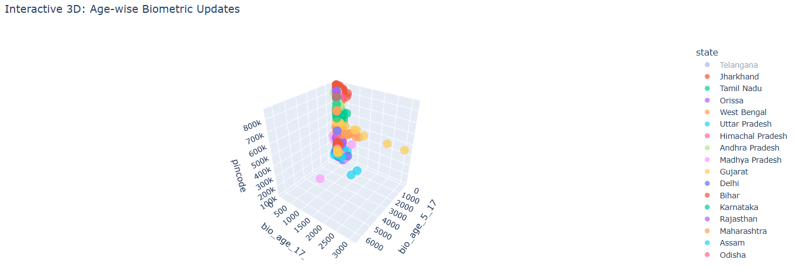
Interactive 3D scatter plot illustrating age-wise Aadhaar biometric update patterns across states, highlighting variation in biometric update intensity by age group and geographic region.
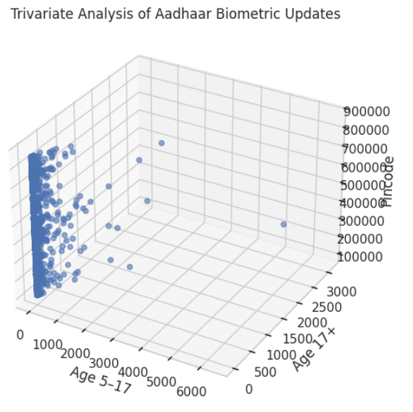
Trivariate analysis of Aadhaar biometric updates illustrating the relationship between age groups and geographic distribution (PIN codes), highlighting age-dependent variability in biometric update activity.
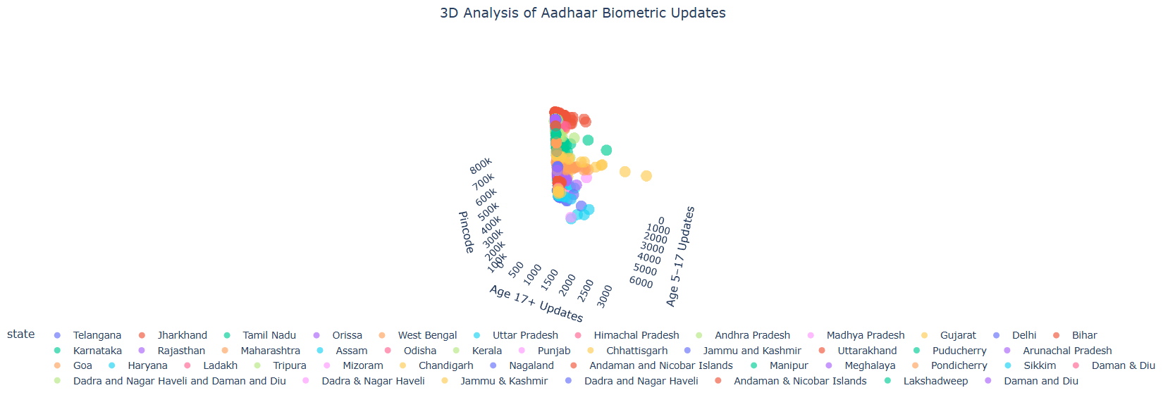
3D visualization of Aadhaar biometric update activity across age groups and PIN codes, highlighting age-dependent biometric update intensity and inter-state variation.

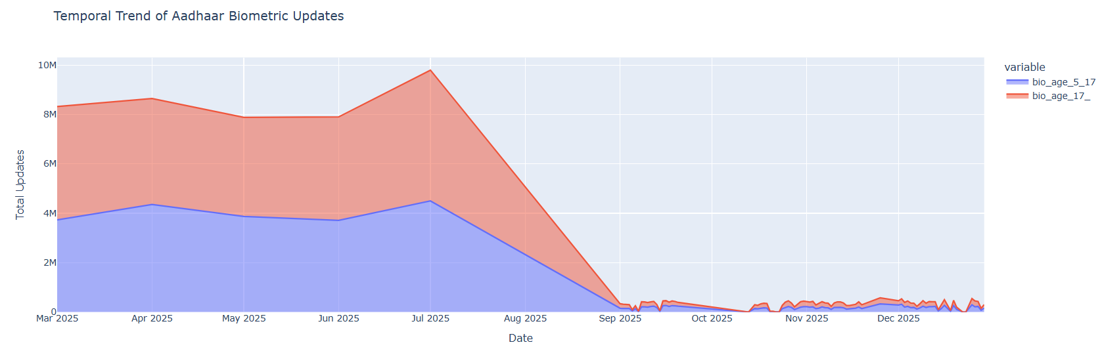
Temporal trend of Aadhaar biometric updates across age groups (5–17 and 17+), illustrating age-wise variation and temporal shifts in biometric update activity over the study period.

**Age-wise biometric update patterns and anomaly detection were analyzed using the Biometric Analysis Notebook (Appendix C).
4.4 Cross-Dataset Observations
- Regions with a lot of enrolments usually see more updates too, which means the service load piles up in those areas.
- When you look at the timing, those bursts in enrolment and update activity often line up—they probably happen because of new policies or seasonal trends.
- And those weird jumps or sudden drops you see? They point out exactly where teams need to step in and take action.
4.5 Visualisations Developed
Here’s what we put together for the submission:
- We made time-series line charts to track enrolment and update trends.
- There are bar charts that break things down by state and district, plus heatmaps so you can spot where activity is the highest.
- You’ll also find age-group distribution plots and some visuals that flag anomalies.
All these visuals came straight from our submitted notebooks and we included them in the final report.

Conclusion and Recommendations
This study shows how Aadhaar enrolment and update data actually say a lot about how people behave, move, and interact with India’s digital identity system. When you look at the numbers—enrolments, demographic updates, biometric changes—you start to see clear patterns. Some regions stand out, some age groups update more than others, and demand isn’t the same all year. Demographic updates usually spike around big life events—like when people move or need to update documents. Biometric changes? Those go up as people get older, mostly because fingerprints and other biometrics just don’t stay the same forever. And when you dig into the data, you spot weird spikes or sudden drops in activity in certain areas, which usually points to either an operational issue or a new policy kicking in.

So, what do you do with all this? UIDAI should really lean into this data. Plan infrastructure and resources based on what the numbers actually show. If a region keeps showing high update volumes, give it more resources—don’t wait for complaints. If some districts keep showing anomalies, send in teams or extra support to figure out what’s up. For older users, set up more frequent biometric refreshes so they don’t run into authentication problems. And don’t just react—use predictive analytics and real-time dashboards to spot trends early and stay ahead of the curve. In the end, using Aadhaar’s own data in smart ways doesn’t just make the system work better; it means people get services faster, with fewer headaches, and policies actually match what’s happening on the ground.

References / Appendix
Appendix A: Aadhaar Enrolment Analysis Notebook
- Title: Exploratory Data Analysis of Aadhaar Enrolment Data
- Description: Contains data cleaning, preprocessing, state-wise and temporal analysis, anomaly detection, and visualisations related to Aadhaar enrolment.
- Tool Used: Python (Pandas, NumPy, Matplotlib, Seaborn)
- File Name: EDA_Aadhaar_Enrolment.ipynb
- File Link: Notebook_Link

Appendix B: Aadhaar Demographic Update Analysis Notebook
- Title: Exploratory Analysis of Aadhaar Demographic Updates
- Description: Includes state-wise, district-wise, age-group analysis, 3D visualisations, and heatmaps for demographic update patterns.
- Tool Used: Python (Pandas, NumPy, Matplotlib, Plotly)
- File Name: EDA_Aadhaar_Demographic.ipynb
- File Link: Notebook_Link

Appendix C: Aadhaar Biometric Update Analysis Notebook
- Title: Analysis of Aadhaar Biometric Update Trends
- Description: Covers age-wise biometric updates, temporal trends, trivariate analysis, and anomaly detection related to biometric ageing.
- Tool Used: Python (Pandas, NumPy, Matplotlib, Plotly)
- File Name: EDA_Aadhaar_Biometric.ipynb
- File Link: Notebook_Link

